# Kubernetes - Creating an App

In order to create an application for Kubernetes deployment, we need to first create the application on the Docker. This can be done in two ways −

* By downloading
* From Docker file

## By Downloading

The existing image can be downloaded from Docker hub and can be stored on the local Docker registry.

In order to do that, run the Docker **pull** command.

$ docker pull --help

Usage: docker pull [OPTIONS] NAME[:TAG|@DIGEST]

Pull an image or a repository from the registry

-a, --all-tags = false Download all tagged images in the repository

--help = false Print usage

Following will be the output of the above code.

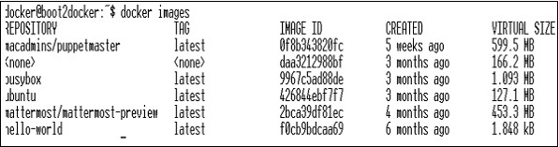

The above screenshot shows a set of images which are stored in our local Docker registry.

If we want to build a container from the image which consists of an application to test, we can do it using the Docker run command.

$ docker run –i –t unbunt /bin/bash

## From Docker File

In order to create an application from the Docker file, we need to first create a Docker file.

Following is an example of Jenkins Docker file.

FROM ubuntu:14.04

MAINTAINER vipinkumarmishra@virtusapolaris.com

ENV REFRESHED_AT 2017-01-15

RUN apt-get update -qq && apt-get install -qqy curl

RUN curl https://get.docker.io/gpg | apt-key add -

RUN echo deb http://get.docker.io/ubuntu docker main > /etc/apt/↩

sources.list.d/docker.list

RUN apt-get update -qq && apt-get install -qqy iptables ca-↩

certificates lxc openjdk-6-jdk git-core lxc-docker

ENV JENKINS_HOME /opt/jenkins/data

ENV JENKINS_MIRROR http://mirrors.jenkins-ci.org

RUN mkdir -p $JENKINS_HOME/plugins

RUN curl -sf -o /opt/jenkins/jenkins.war -L $JENKINS_MIRROR/war-↩

stable/latest/jenkins.war

RUN for plugin in chucknorris greenballs scm-api git-client git ↩

ws-cleanup ;\

do curl -sf -o $JENKINS_HOME/plugins/${plugin}.hpi \

-L $JENKINS_MIRROR/plugins/${plugin}/latest/${plugin}.hpi ↩

; done

ADD ./dockerjenkins.sh /usr/local/bin/dockerjenkins.sh

RUN chmod +x /usr/local/bin/dockerjenkins.sh

VOLUME /var/lib/docker

EXPOSE 8080

ENTRYPOINT [ "/usr/local/bin/dockerjenkins.sh" ]

Once the above file is created, save it with the name of Dockerfile and cd to the file path. Then, run the following command.

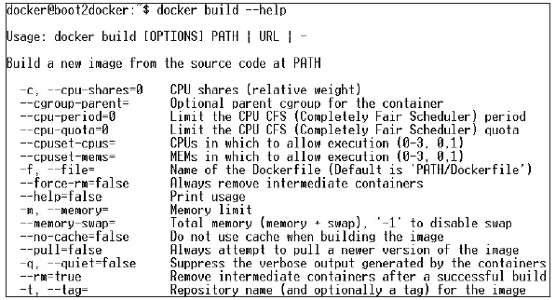

$ sudo docker build -t jamtur01/Jenkins .

Once the image is built, we can test if the image is working fine and can be converted to a container.

$ docker run –i –t jamtur01/Jenkins /bin/bash